8.100: a) With block B initially at rest, 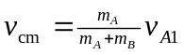. b) Since there is no net external force, the center of mass moves with constant velocity, and so a frame that moves with the center of mass is an inertial reference frame. c) The velocities have only -components, and the -components are . Then,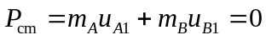.
d) Since there is zero momentum in the center-of-mass frame before the collision, there can be no momentum after the collision; the momentum of each block after the collision must be reversed in direction. The only way to conserve kinetic energy is if the momentum of each has the same magnitude so in the center-of-mass frame, the blocks change direction but have the same speeds. Symbolically, 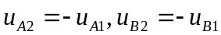. e) The velocities all have only –components; these components are and 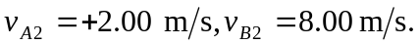 and Equation (8.24) predicts 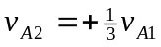 and Eq. (8.25) predicts 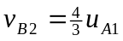, which are in agreement with the above.

